Use-Case Realization Report
DeleteUser

Issue <1.0>
Revision History
Date | Issue | Description | Author
<dd/mmm/yy> | <x.x> | <details> | <name>

Table of Contents
1. Brief Description 4
2. Flow of Events 4
2.1 Standard Flow 4
2.2 Exceptions 4
3. Interaction Diagrams 5
3.1 Collaboration Diagram for DeleteUser 5
4. Participating Objects 5
5. Class Diagrams 6
5.1 Class Diagram for DeleteUser 6
6. Derived Requirements 6

Use-Case Realization Report
DeleteUser

Brief Description
The deletion of User shall be executed once the selection check for the existing User list was performed.

Flow of Events

Standard Flow
This use case covers the events of deleting User, which is part of the User Maintenance package. The standard flow of events is described as below:
- The User Administrator shall press the button to send out a command of “deleteButtonClicked” on the interface of MaintainUserPage.
- Once MaintainUserController received this request, the operation checkUserToDelete will check if there’s User Admin seleted.
- Then the operation getUser will get the User from object of User.
- The operation deleteUser will delete the selected one from the list.
- Then the operation updateUserList of the MaintainUserController will update the new list of User object
- Once it’s done, the successful updating userList will show to the MaintainUserPage.

Exceptions

- If there’s no selection found in User Admin records, a warning message will be show to the MaintainUserPage through the operation showNoUserSelectedMsg.

Interaction Diagrams

Collaboration Diagram for DeleteUser
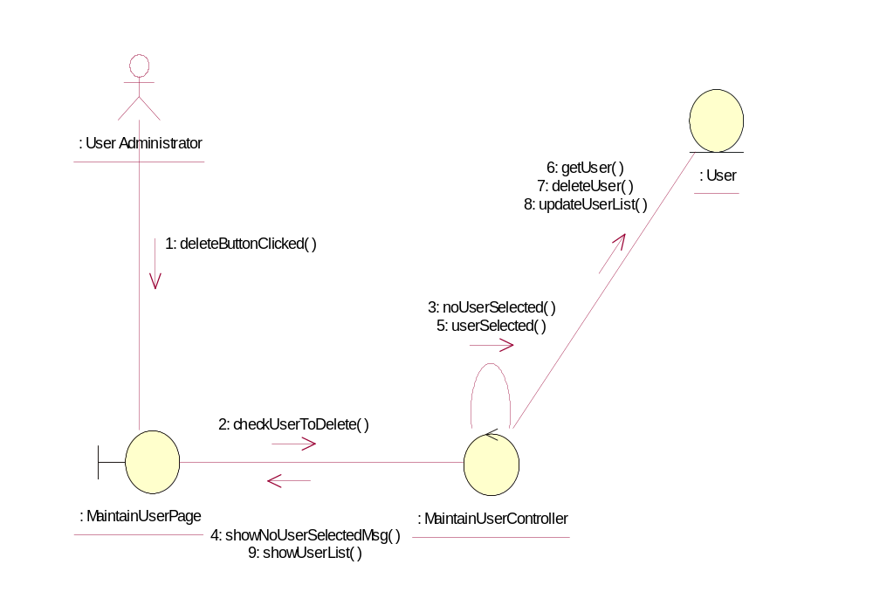

Participating Objects
: MaintainUserController
This controller is to add, delete and update User

: MaintainUserPage
This is a page for adding, deleting, updating and displaying the User

: User
This Entity is User Object

: User Administrator
This actor is User Administrator object

Class Diagrams

Class Diagram for DeleteUser
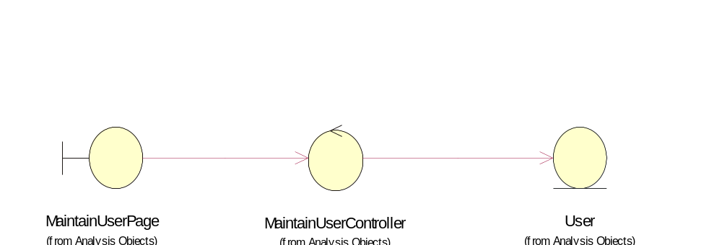

Derived Requirements
Portal Administrator and User Administrator have rights to access this page

